**Name:_________________________ Date:_______________ Per._______ Score:_____**

**U9 HW #3** *Who Will Win?*

1. Gabriela and Camila like to race each other. Gabriela can run 10 feet/second while Camila can run 12 feet/second. Being a good sport, Camila gives Gabriela a 20-foot head start.
   1. Identify the variables and create a system of linear equations and graph on the graph to the right.
   2. If the girls are racing to a tree that is 30 yards away, who will win the race? (*Remember there are 3 feet in 1 yard)*.
2. Darnell and Lance are both saving money. Darnell currently has $40 and is saving $5 each week. Lance has $25 and is saving $8 each week.
   1. Identify the variables and create a system of linear equations and graph on the graph to the right. (Use a different color than you did for problem #1)
   2. When will Darnell and Lance have the same amount of money? (Hint: set the equation equal to each one another.)
   3. If both boys continue saving at this rate, who will have $100 first? (Approximate if necessary)

**Hint: number both x & y axis by 5 to make both graphs work better.**

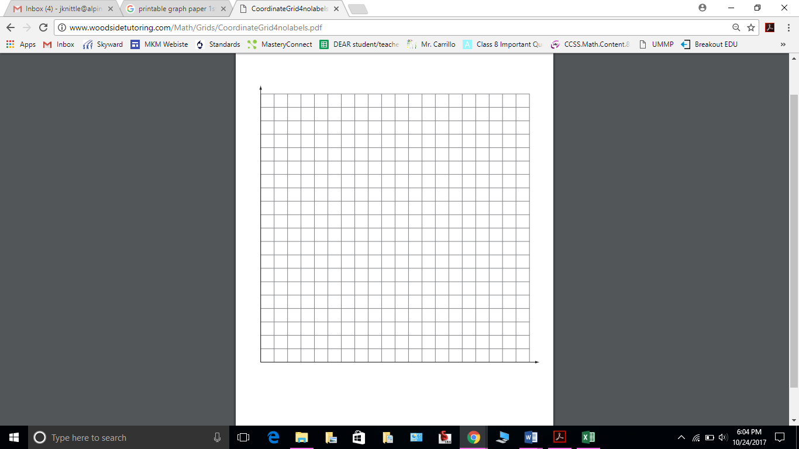

1. The graph below shows the amount of money Charlie and Dom have in savings.
2. Write an equation to represent the amount *y* that each person has in savings after *x* weeks:

Charlie: _____________________ Dom: _________________________



1. Tell the story of the graph.

**Charlie**

**Dom**

1. Lakeview Middle School is having a food drive. The graph below shows the number of cans each class has collected for the food drive with time 0 being the start of week 3 of the food drive.
   1. Write an equation to represent the number of cans *y* that each class has

collected after *x* days.

Mrs. Lake’s Class: _____________________ Mr. Luke’s Class: _____________________



* 1. Tell the story of the graph.

Mr. Luke

Mrs. Lake

Trend Line Review

1. Using the information below –
   1. Create the scatterplot.
   2. Draw a trend line using a ruler.
   3. What is the equation of the trend line in slope-intercept form (y = mx + b)?
   4. According to your trend line, answer the question below.

