**Name:_________________________ Date:_______________ Per._______ Score:_____**

**U4 HW # 4** *Finding Slope from Two Points*

Graph the following pairs of points. Use the graph to determine the slope.

|  |  |
| --- | --- |
| 1. (-4, 3) and (2, 6)     *m*= | 1. (-1, 4) and (0, 1)     *m* = |

Calculate the slope of the line connecting each pair of points. Show the formula you use and your work!

|  |  |
| --- | --- |
| 1. ( 1, 42) and (4, 40) | 1. (-21, -2) and (-20, -5) |
| 1. (3, -10) and (-6, -10) | 1. (10, -11) and (11, -12) |
| 1. (5, 1) and (-7, 13) | 1. (14, -3) and (14, -7) |
| 1. (8, 41) and (15, 27) | 1. (17, 31) and (-1, -5) |
| 1. (-5, 36) and (-4, 3) | 1. (32, -23) and (-6, -2) |

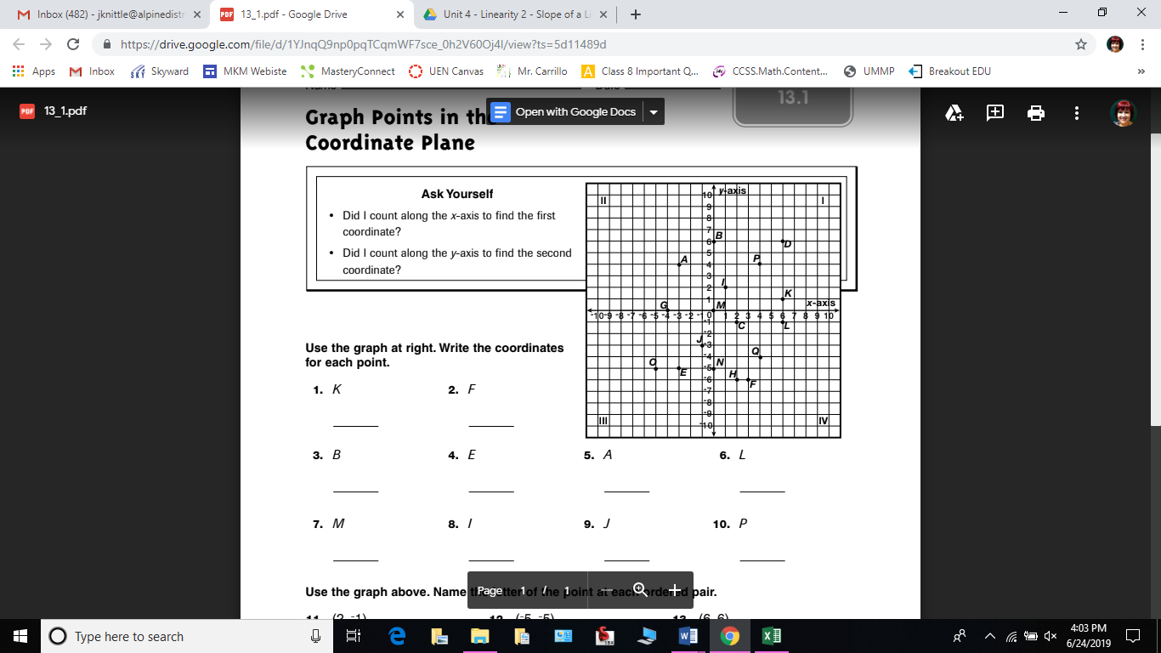

**Directions:** Using the graph above, identify the coordinate pair for each point.

1. K _________
2. F _________
3. B _________
4. E _________
5. A _________
6. L _________
7. M _________
8. I _________
9. J _________
10. P _________

Directions: Using the graph above, identify the letter of the point at each ordered pair.

1. (2, -1) __________
2. (-5, -5) __________
3. (6, 6) __________
4. (-4, 0) __________
5. (0, -5) __________
6. (4, -4) _________

Directions: Label the quadrant of the given coordinate point, using QI, QII, QIII, or QIV.

1. (-1, 5) __________
2. (-8, -3) __________
3. (10, 1) __________
4. (4 -7) __________