Name: _________________________ Date: _____________ Per: ______ Score: _______
U13 HW #2 Solving Literal Equations
Directions: Solve each of the following for the given variable. Show all steps. Check your work by using the answer bank on the bottom. Cut the squares apart and glue each matching answer to the corresponding box.
Solve for x:  $$x+a=b$$ | Solve for x:  $$ax+b=c+d$$ | Solve for x:  $$bx-5=c$$
Solve for y:  $$36=byx$$ | Solve for x:  $$s=4x$$ | Solve for x:  $$cx-d=4$$
Solve for y:  $$x+sy=t$$ | Solve for x:  $$m=2(x+n)$$ | Solve for x:  $$4x-5c=3c$$
Solve for x:  $$abx-d=5d$$ | Solve for x:  $$3x-s=r$$ | Solve for y:  $$\frac{y}{4}=c$$

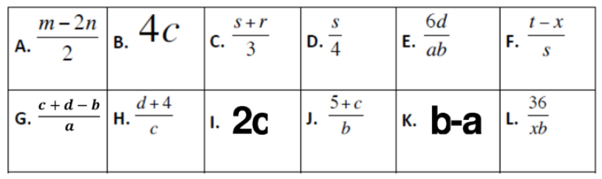
Directions: Rearrange the following formulas to solve for the unknown.
- The formula to find the Area of a Triangle is $A=\frac{1}{2}bh$  Solve the equation to find the height. | - The formula for the Area of a circle is  $$A=πr^{2}$$  Solve the equation to find the radius.
- The formula for the Volume a sphere is  $$V=\frac{4}{3}πr^{3}$$  Solve the equation to find the radius. | - The formula for the Volume of a cone is  $$V=\frac{1}{3}πr^{2}h$$  Solve the equation to find the height.
- The formula for the Circumference of a circle is C$=2πr$  Solve the equation to find the radius. | - The formula for the Volume of a Cylinder is  $$V=πr^{2}h$$  Solve the equation to find the radius.

