Name:_________________________ Date:_______________ Per._______ Score:_____
U11 HW #3 Multiply and Divide Like bases with Exponents

- For parts a. through c. write each expression in expanded form. Then write the simplified expression in exponential form.

# | Expression | Expanded Form | Exponential Form
 | $$3^{2}•3^{3}$$
 | $$x^{4}x^{6}$$
 | $$x^{2}y^{2}•x^{4}$$
 | $$a^{3}b^{2}∙a^{3}b^{5}$$
 | $$abc•a^{2}bc^{2}$$

- For parts a. through c. write each expression in expanded form. Then write the simplified expression in exponential form.

# | Expression | Expanded Form | Exponential Form
 | $$\frac{4^{3}}{4^{2}}$$
 | $$\frac{x^{2}}{x^{6}}$$
 | $$\frac{a^{4}b^{7}}{a^{3}b^{6}}$$
 | $$\frac{s^{2}t^{3}}{t^{7}u}$$
 | $$\frac{{5^{4}a}^{4}b^{2}}{5^{3}{ab}^{2}}$$
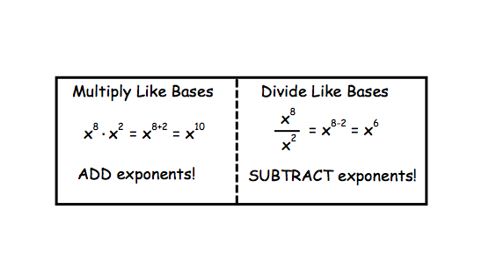
- Try these using the Exponent Rules:
Show All the Steps. All answers must have positive exponents.

- ${(y}^{50}{)(y}^{200})$ | - $a^{13}b^{54}{∙a}^{-3}b^{20}$
- $\frac{{bc}^{200}}{b^{100}c^{146}}$ | - $\frac{p^{-10}r^{20}}{p^{30}r^{17}}$
- $2^{4}∙2^{-5}∙5^{0}$ | - ${\left(\frac{2}{5}\right)}^{-3}$

