**Name:_________________________ Date:_______________ Per._______ Score:_____**

**U8 CW #1** *Introduction to Functions*

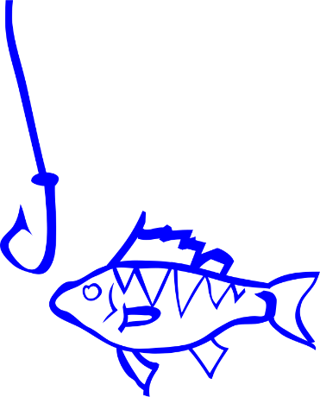Example #1 - Jason is spending the week fishing at the Springville Fish Hatchery. Each day he catches 3 fish for each hour he spends fishing. This relationship can be modeled by the equation $y =3x$*,* where *x* = number of hours spent fishing and *y* = the number of fish caught.

* 1. Complete the graph and table below for this relationship.

|  |  |
| --- | --- |
| Number of hours spent fishing  *x* | Number of fish caught  *y* |
| 3 |  |
| 2 |  |
| 1 |  |
| 2 |  |
| 0 |  |
| 4 |  |

The situation above is an example of a **function**.

We would say that *the number of fish caught is a* ***function*** *of the number of hours Jason spends fishing.*

Example #2 - Sean is also spending the week fishing; however, he is fishing in the Bear River. Each day he records how many hours he spends fishing and how many fish that he caught. The table of values below shows this relationship.

* 1. Complete the graph for this relationship.

|  |  |
| --- | --- |
| Number of hours spent fishing  *x* | Number of fish caught  *y* |
| 1 | 4 |
| 0 | 0 |
| 2 | 5 |
| 3 | 1 |
| 3 | 8 |
| 5 | 5 |

This situation is an example of a relation that is **not a function**.

The number of fish that Sean catches is **not** a function of the number of hours he spends fishing.

**Compare and contrast the relationship for Jason’s week spent fishing and Sean’s week spent fishing. Make a conjecture (an educated guess) about what kind of relationship makes a function and what disqualifies a relation from being a function**.

Example #3 - Vanessa is buying gumballs at Vincent’s Drug Store. The mapping below shows the relationship between number of pennies, or *x*, she puts into the machine and the number of gumballs she gets out, or *y*.

|  |  |
| --- | --- |
| *x* | *y* |
| 1  2  3  4  2  4  6  8 | |

* 1. Complete the graph and table below for this relationship.

|  |  |
| --- | --- |
| Number of pennies  *x* | Number of gumballs  *y* |
|  |  |
|  |  |
|  |  |
|  |  |

* 1. Write an equation that models this relationship.

This is also an example of a **function.**

We would say that *the number of gumballs received is a* ***function*** *of the number of pennies put in the machine.*

Example #4 - Kevin is across town at Marley’s Drug Store. The mapping below relates the number of pennies he puts into the machine and how many gumballs he gets out.

|  |  |
| --- | --- |
| *x* | *y* |
| 1  2  3  2  3  4  6 | |

* 1. Complete the graph and table below for this relationship.

|  |  |
| --- | --- |
| Number of pennies  *x* | Number of gumballs  *y* |
|  |  |
|  |  |
|  |  |
|  |  |

This situation is an example of a relation that is **not a function**.

Example #5 - Cody is at Ted’s Drug Store. The graph below relates the number of pennies he puts into the machine on different occasions and how many gumballs he gets out.



* 1. Explain how this gumball machine works.
  2. In this example, is the number of gumballs received a function of the amount of money put in? Explain your answer.

**Compare and contrast the relationship of the gumball machines at the different drugstores. If needed revise your conjecture about what kind of relationship makes a function and what disqualifies a relationship from being a function. (On the 1st page)**

Example #6 - The cost for entry into a local amusement park is $45. Once inside, you can ride an unlimited number of rides.

Complete the graph and table below for this relationship.

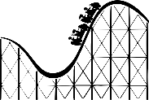

|  |  |
| --- | --- |
| Number of rides  *x* | Amount spent (dollars)  *y* |
|  |  |
|  |  |
|  |  |
|  |  |
|  |  |

* 1. Is the amount one spends a function of the number of rides he/she goes on? Why or why not?

Example #8 - The table below show the number of hours Owen plays his favorite video game and the number of points he scores.

|  |  |
| --- | --- |
| Time Spent Playing  (hours) | Number of Points Scored |
| 1 | 5,000 |
| 1 | 5,550 |
| 1 | 6,500 |
| 2 | 11,300 |
| 2 | 12,400 |
| 3 | 15,000 |

* 1. Is the number of points Owen scores a function of the amount of time he spends playing? Why or why not?

**Below is a formal definition of a function. As you read it compare it to the conjecture you made about what makes a relation a function.**

**Given two variables, *x* and *y*, *y* is a function of *x***

**if there is a rule that determines one unique *y* value for a given *x* value.**

Describe in your own words what is a function?