Name: _______________________________ Date: _______________ Per._______

**U5 CW #2 *Write and Graph in Slope-Intercept Form***

The equation of a line written in the form **y = mx + b** is said to be in slope-intercept form. Sometimes we will be given equations that are not written in slope-intercept form. For example, you might be given an equation like 3x+2y=6, this is said to be in standard form, **Ax + By = C**.

**Directions:** Classify the form of each linear equation as standard or slope-intercept.

|  |  |  |  |
| --- | --- | --- | --- |
| $x+y=-15$ | $2y+8x=1$ | $y=3x-2$ | $y=1$ |

Graph the equation given below. Be ready to discuss your ideas with the class.



*4x+2y=8*

Write down how to graph an equation that is not written in Slope-Intercept Form in the space below.

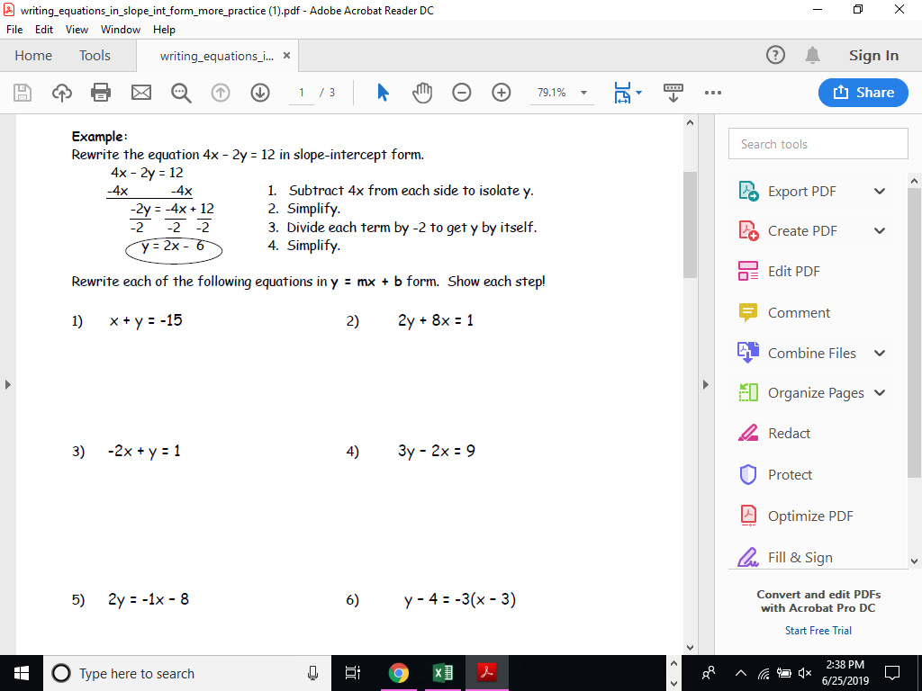

|  |
| --- |
| 1. Graph  HINT: Isolate the y using inverse operations. |
| 1. Graph  HINT: Isolate the y using inverse operations. |
| 1. Graph |
| 1. Graph |
| 1. Graph |

1. The Hernandez family wants to eat out on Monday night. Salads cost $8.00 each and sandwiches cost $6.00 each. They have a gift card for $42 and want to spend all of it. Let *x* represent the number of salads that the family can buy and *y* represent the number of sandwiches that they can buy.
2. Write an equation that represents all the possible combinations of salads and sandwiches that they can buy with $42.
3. **Graph this equation to show all the different salad and sandwich combinations.



1. What do the ordered pairs on the graph represent?
2. List the realistic combinations for the order. Mark the ordered pairs on the graph that represent these combinations. Explain why these are the only solutions that would work in the real world.

“Every day do something that will inch you closer to a better tomorrow.” –Doug Firebaugh