Name:_________________________ Date:_______________ Per._______
U4 CWK # 5 Finding the Slope of a Line (Table)
Calculate the slope of the line on each graph.
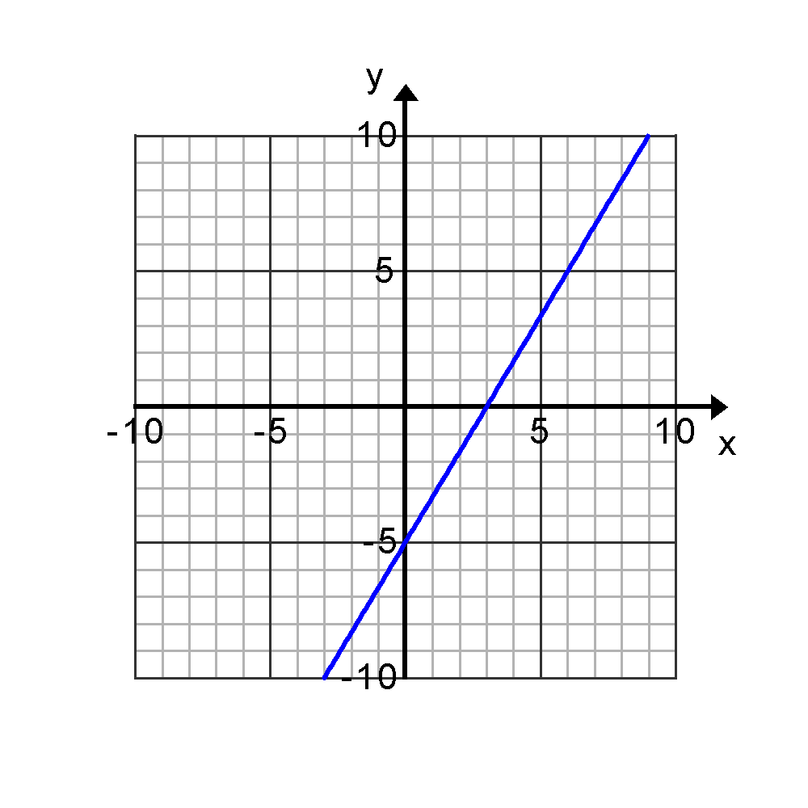  m = | 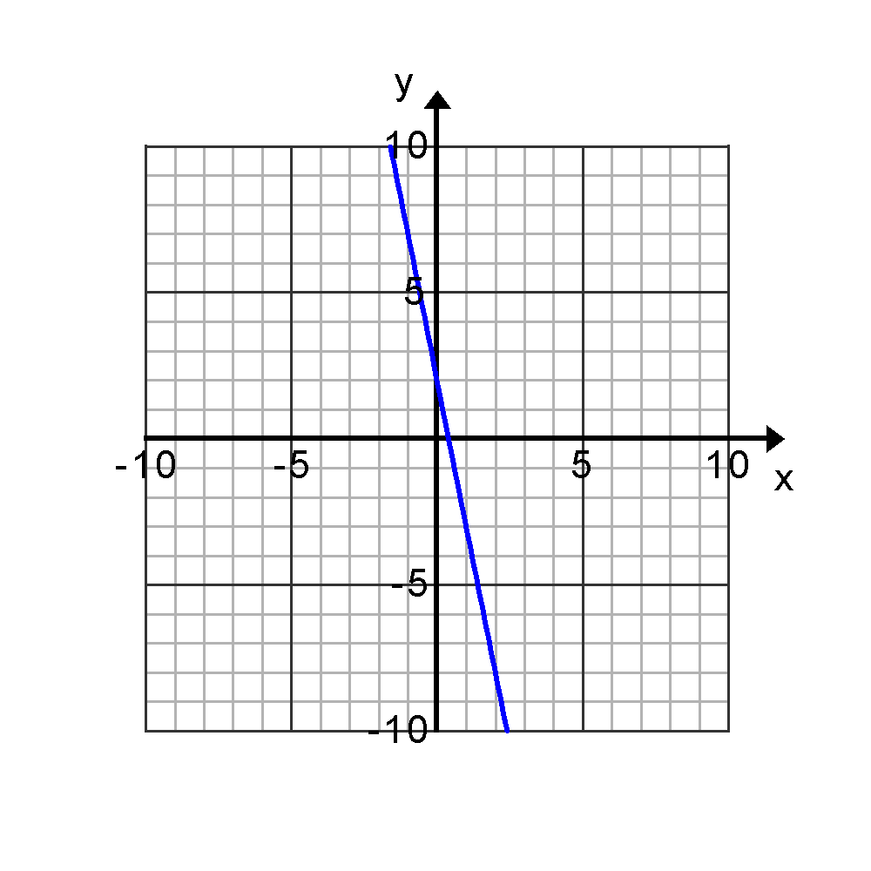  m=

For each pair of points, calculate the slope of the line passing through each pair using the slope formula.

- (10, -6) and (-5, 4) | - (7, 3) and (-3, 0)
- (0, 4) and (1, 0) | - (-5, 1) and (-5, -2)

Now: For problems 3-6 Find one other point that lies on the line containing the given points.

3b. 4b. 5b. 6b.

How did you find another point? Discuss with a partner the strategy you used. What was the same? What was different?

Calculate the slope of the line that contains the points given in each table. Calculate the slope twice, one time by using the Slope Formula with two points and the other time by finding the rate of change or unit rate in the table.

x hours y miles  3 4  4 5  5 6  6 7  m=__________  unit rate =__________ | x hours y dollars  0 4  1 9  2 14  3 19  m=________  rate of change=________
x minute y pages  0 9  3 12  6 15  9 18  m=________  rate of change=________ | x gallons y miles  2 4  4 12  6 20  8 28  m=_______  unit rate=_______
- Why are the slopes the same no matter what two points you use to find the slope?

