**Name: _________________________________ Date: _______________ Per._______**

**U3 CWK #1:** *Ordered Pairs and Graphing*

**Directions:** Match the following definition to the term, then label the grid where appropriate for each term.

1. a grid created when the x- and

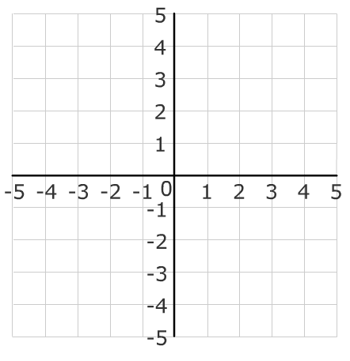 y-axis cross at zero

1. the point where the two axes, x & y, cross at (0,0)

B



1. the vertical axis of the grid

A



1. representation of the distance from the origin written as (x, y)
2. the horizontal axis of the grid
3. one section of the coordinate grid

G

C





Coordinate Grid: ____

Ordered Pair: ____

EE



Origin: ____

F



x-axis: ____

y-axis: ____

D



Quadrant: ____

**Moving Around the Coordinate Grid:**

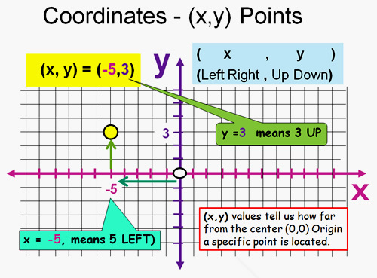

**ALWAYS** start at the origin (0, 0) move left or right along the x-axis then up or down along the y-axis.

*Remembe*r: All Points are written as the number of x and y moves away from the origin separated by a comma and in parenthesis.

**Example: ( x , y )**

**Directions:** Identify the coordinates of each point from the graph to the left:

Point A: ( ____ , ____ )

Point C: ( ____ , ____ )

Point E: ( ____ , ____ )

Point B: ( ____ , ____ )

Point D: ( ____ , ____ )

Point F: ( ____ , ____ )

Point G: ( ____ , ____ ) or _______________

**Positive / Negative direction on the Coordinate Grid:**

Quadrant II Quadrant I

When you move left on the When you move right on the

x-axis the x value is negative (-) x-axis the x value is positive (+)

When you move up on the When you move up on the

y-axis the y value is positive (+) y-axis the y value is positive (+)

( -x, y ) ( x, y )

Quadrant III Quadrant IV

When you move left on the When you move right on the

x-axis the x value is negative (-) x-axis the x value is positive (+)

When you move down on the When you move down on the

y-axis the y value is negative (-) y-axis the y value is negative (-)

( -x, -y ) ( x, -y )

What quadrant would you find each of the coordinate pairs in?

(Use the format QI, QII, QIII, or QIV)

* (-13, 17) _________
* (21, 23) _________
* (11, -32) _________
* (-14, -2) _________
* (-8, 12) _________
* (-9, -12) _________
* (54, 49) _________
* (4, -10) __________
* (-4, -1) _________

