Name:____________________________________ Date:_______________ Per._______
U12 CW #4 Operations with Radicals

Early in the year, we learned how to combine like terms. Using the skills, you learned, put the following algebraic expressions into their simplest form.

$-6x-4+5x+7$ $2x+3+4x$

How did you simplify the above expressions? How do you know when an expression is in simplest form?

What if I asked you to simplify an expression that had a radical as a term?
$$2\sqrt{3}+3\sqrt{3}$$
Brainstorm: What are some ideas for how you might simplify the expression above.

Square-root expressions with the same radicand are examples of like radicals.
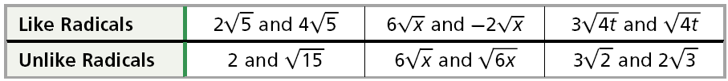
Helpful Hint
Combining like radicals is similar to combining like terms.

Like radicals can be combined by adding or subtracting.
Example:
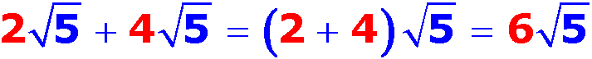

Notice that you can combine like radicals by adding or subtracting the numbers multiplied by the radical and keeping the radical the same. Let’s try one.

Simplify: $2\sqrt{3}-\sqrt{3}+\sqrt{2}$

Directions: Simplify the following expression. Keep your final answer is in simplest form.

$$9\sqrt{3}-4\sqrt{3}$$ | $$5\sqrt{11}-4\sqrt{11}$$ | $$\sqrt{15}+\sqrt{15}+2$$

Sometimes you will be asked to add or subtract radical terms that are not in their simplest forms at the beginning of the problem. When you are presented with problems like this, you need to get the radicals in their simplest radical form BEFORE you add and/or subtract like radical terms. Remember to use the methods we learned in the last lesson to get the radicals in their simplest forms.

Directions: Simplify the following expression to its simplest form. SHOW ALL STEPS!!!!!

1. $\sqrt{45}-\sqrt{20}$ | 2. $\sqrt{54}+\sqrt{24}$
3. $5\sqrt{3}+\sqrt{12}$ | 4. $3\sqrt{18}+10\sqrt{2}$
Let’s look at some examples that include multiplication and division. Put the following algebraic expressions into their simplest form.

$-6(x-4)$ $2x•4x•3$ $\frac{4x•3}{12}$

How did you simplify the above expressions? How do you know when an expression is in simplest form?

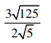
What if I asked you to simplify an expression that had a radical as a term?
$\sqrt{24}•\sqrt{8}$ or

Brainstorm: What are some ideas for how you might simplify the expressions above.

Just like in expressions and combining like terms, the rules for multiplying and dividing are simpler than the rules for adding and subtracting.

Let’s look at the examples worked out:
$Ex: \sqrt{24} •2\sqrt{8}$ $\frac{3\sqrt{125}}{2\sqrt{5}}$

- Multiply/Divide any numbers outside the radical together and any numbers under the radical together.

- Simplify under the radical by taking out the largest perfect square and leaving it in simplest radical form.

- Do any math. Multiply any numbers outside the radical together.

Let’s try one:
Simplify: $\frac{\sqrt{5}\left(\sqrt{7}•\sqrt{5}\right)}{5}$

$1•2•\sqrt{24•8}$ $\frac{3}{2} • \frac{\sqrt{125}}{\sqrt{5}}$
$2\sqrt{192}$ $\frac{3}{2} • \sqrt{25}$
$2\sqrt{64•3}$ $\frac{3}{2}•5$
$2•8\sqrt{3}$ $\frac{15}{5}$
$16\sqrt{3}$

Directions: Simplify the following expression. Keep your final answer is in simplest form.

$$6\sqrt{15}•5\sqrt{35}$$ | $$\frac{4\sqrt{42}}{-2\sqrt{7}}$$ | $$\frac{\sqrt{18}•\sqrt{8}}{2}+2\sqrt{2}$$

Sometimes you will be asked to add or subtract radical terms that are not in their simplest forms at the beginning of the problem. When you are presented with problems like this, you need to get the radicals in their simplest radical form BEFORE you add and/or subtract like radical terms. Remember to use the methods we learned in the last lesson to get the radicals in their simplest forms.

Directions: Simplify the following expression to its simplest form. SHOW ALL STEPS!!!!!

5. $\sqrt{10}\left(\sqrt{5}+\sqrt{2}\right)$ | 6. $\frac{3\sqrt{15}}{5\sqrt{5}}$
7. $\sqrt{6}\left(4\sqrt{6}\right)-\sqrt{12}$ | 8. $\frac{\sqrt{18}}{2}+10\sqrt{2}$

