**Name:___________________________________ Date:_______________ Per._______**

**U1 CW #4** Solving Multi-Step Linear Equations with Variables on Both Sides

Today we will continue our work with equations. We will work on solving equations that have variables on both sides of the equal sign. The key to solving these types of equations is to *move* all the terms containing the variable to one, and only one, side.

Goal: Use Inverse Operations to get all variable terms on one side of = sign and all constant terms on the other side of the = sign.

1. Use Distributive Property, if necessary.
2. Combine like terms on each side of the = sign, if necessary
3. Move all variable terms to one side of = by adding its inverse to both sides of = sign.
4. Solve as usual using inverse operations to get the variable alone.

|  |  |
| --- | --- |
|  | Original problem |
| Move variables to one side of = sign |
|  |
| Move constants to the other side of = sign |
| Use inverse operations to ensure the coefficient of the variable is 1. |
| Solution |

|  |  |
| --- | --- |
|  | Original Problem |
| Do the Distributive Property First!!! |
| Move variables to one side of = sign |
|  |
| Eliminate adding or subtracting using inverse operations |
| Eliminate multiplying or dividing using inverse operations. |
| Solution! |

*** It doesn't matter which side you choose. Just try to pick the easier one.

Let’s try a couple together.

**Directions:** Solve the following equations. **SHOW ALL STEPS, PLEASE!!!**

|  |  |
| --- | --- |
| 1. $4x=2x+12$ | 2. $5(x+3)=x+27$ |

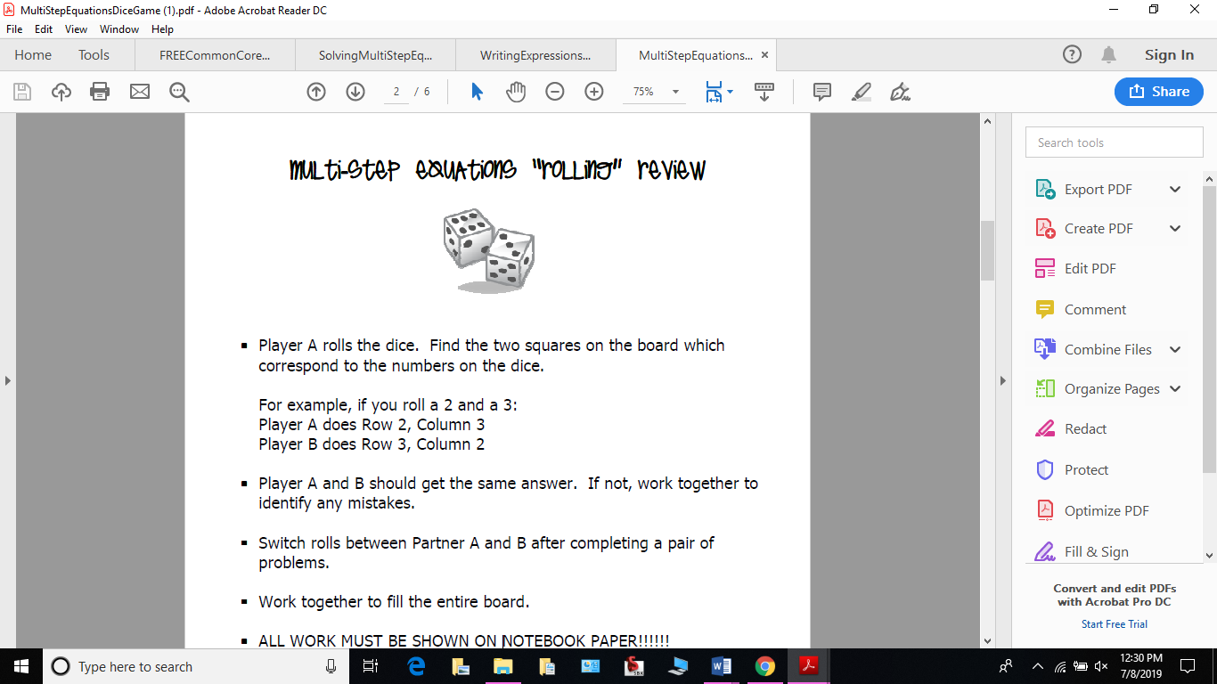

Classroom Activity Directions:



ALL WORK FOR PROBLEMS MUST BE SHOWN ON BACK OF THIS PAPER.