Name:_______________________ Date:_____________Period:________ Score:_____

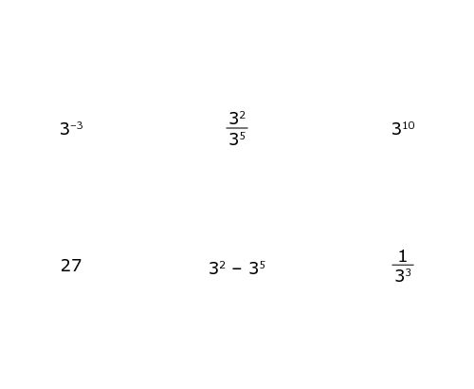

INTERMEDIATE II (MATH 8)  *Review*

**1.** Which statement is true about transformations such as rotations, reflections, and translations?

**A.** Angles can be transformed to angles of a different measure.

**B.** Line segments can be transformed to line segments of a different length.

**C.** A figure in one quadrant can be transformed into a figure in a different quadrant.

**D.** Parallel lines can be transformed to lines with different characteristics, such as perpendicularity.

**2.** Select the pair of congruent figures.

**A. B. C. D.**

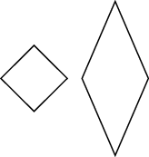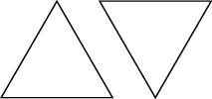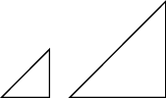





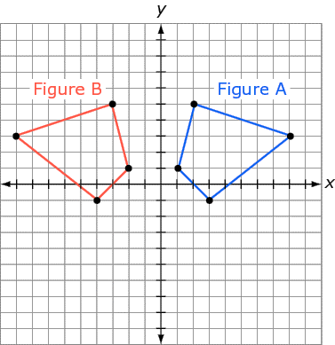

**3.** Which series of transformations would show that Figure A is congruent to Figure B?

**A.** Reflect Figure A over the *x*­axis, then translate it one unit left.

**B.** Reflect Figure A over the *y*­axis, then translate it one unit left.

**C.** Translate Figure A one unit left, then reflect it over the *x*­axis.

**D.** Translate Figure A one unit left, then reflect it over the *y*­axis.

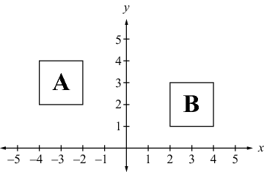**4.** Figure A and figure B are congruent. Which sequence of transformations could move figure A to the same position as figure B?

**A.** A translation 5 units right, then a translation 1 unit down.

**B.** A  rotation about the origin, then a translation 5 units up.

**C.** A translation 1 unit down, then a reflection over the *x­*axis.

**D.** A  rotation clockwise, then a translation 1 unit up.

**6.** A square with vertices at (1,1), (3,1), (3,3) and ((1,3) is reflected over the *x*­axis. What are the square’s vertices after this reflection?

**7.** Triangle QRS is reflected over the *x*­axis, translated 3 units left, and then rotated  clockwise about the origin. Find S', the location of S after the transformations.

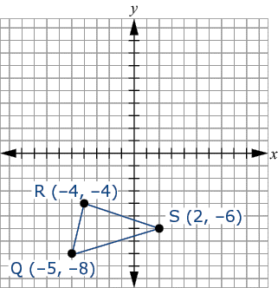**A.** (6,1) **B.** (6,-5)

**C.** (-6,5) **D.** (-6,-1)

**8.** Triangle A’B’C’ is a dilation of triangle ABC with a scale factor of 3 centered about the origin. Draw triangle A’B’C’.

Delete Add Point Connect Line

**12.** A trapezoid is rotated  about the origin, dilated by a factor of 2, and then translated 4 units down. Which statement about the new figure in relation to the original trapezoid must be true?

**A.** The new figure’s vertices are on the same coordinates as the original trapezoid.

**B.** The new figure is congruent to the original trapezoid.

**C.** The new figure is similar to the original trapezoid.

**D.** The new figure is not a trapezoid.

**13.** A translation, then a reflection, followed by a dilation will transform figure A into figure B. What is the relationship between these two figures?

**A.** Figure A and figure B are congruent.

**B.** Figure A and figure B are similar.

**C.** Figure A and figure B are reflections of each other.

**D.** Figure A and figure B have no relationship.

**14.** If a triangle is rotated, dilated, and then translated, which statement must be true?

**A.** The new triangle has vertices with the same coordinates as the original triangle.

**B.** The new triangle is congruent to the original triangle.

**C.** The new triangle has the same perimeter as the original triangle.

**D.** The new triangle is similar to the original triangle.

**15.** A transformation that maps triangle  to triangle  is shown. Which function represents this transformation?

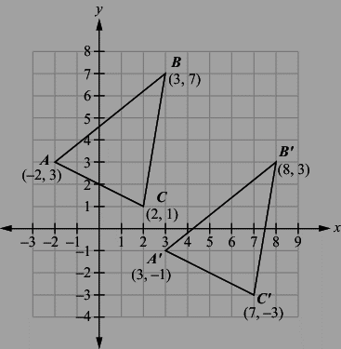

**A.** *f(x, y) = (x + 5, y -4)*

**B.** *f(x, y) = (y + 1, x)*

**C.** *f(x, y) = (y, x + 1)*

**D.** *f(x, y ) =* *(x – 5), y -4)*

**16.** Which action is a rigid transformation?

**A.** shortening the arm of a shirt **B.** playing with a yo­yo

**C.** deflating a balloon **D.** opening a book

**17.** Which set of transformations would create a polygon that is not congruent to the original polygon?

**A.** rotation 360° clockwise **B.** rotation of 55° and then dilation by 2

**C.** translation 3 units left and then 180° rotation **D.** reflection across the *y*­axis and then

translation 2 units right

**18.** A cylindrical water tower has a radius of 15 feet and is 45 feet tall. It has a conical bottom extending another 8 feet from the bottom edge of the cylinder. What is the total volume of the water tower?

**19.** In a galaxy far, far away, there is a planet with a solid spherical core and a gaseous atmosphere that forms a sphere around the core. The core has a radius of 3 megameters, and the distance from the surface to the edge of the atmosphere is another 1.5 megameters. What is the volume of the planet’s atmosphere?

**20.** Paul needs 10 liters of water to water some plants. He has a cylindrical bucket with a height of 30 centimeters and a diameter of 20 centimeters to use. There are 1000 cubic centimeters in a liter. Will all the water he needs fit in the bucket?

**A.** Yes, and the bucket could hold more than 1 liter of additional water.

**B.** Yes, and the bucket could hold less than 1 liter of additional water.

**C.** No, and there will be less than 1 liter of water that does not fit into the bucket.

**D.** No, and there will be more than 1 liter of water that does not fit into the bucket.

**21.** What is the radius of a sphere with a volume of  cubic centimeters?