Name: ____________________________________ Date: ________ Period: _______
Unit 5 Self Start
Use the graph and points below to answer the following questions.  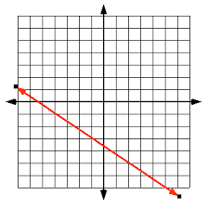  • A  • B  •D  • C | - Using slope triangles, find the slope between:  - Point A and Point B:  __________  - Point A and Point C: __________  - Point B and Point D: __________  - What do you notice about the slopes of the points in problem 1? (write a complete sentence)  - In question #1, you chose two different points to draw your slope triangles. Using your answer from question #2, does it matter which two points you choose? Why?

