Chad was trying to determine how quickly his family goes through a bar of soap in the shower. He took the weight of the soap in the shower over a period of several days.  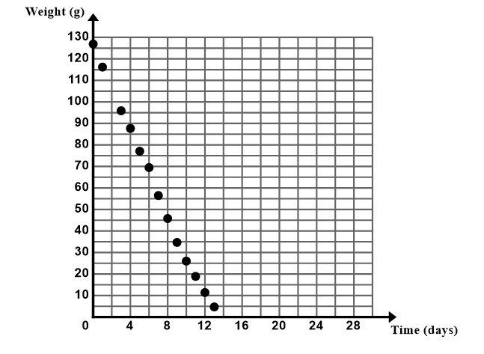 | - Using a ruler, draw a line of best fit through the data points that captures the general trend of the data.  - Estimate the slope and y-intercept of your line.  m $≈$ _______ b $≈$ ______  - Write a prediction function (equation in y=mx+b) for the data set.  - What does the slope represent in the context?  - What does the y-intercept represent in the context?  - Predict the weight of the soap bar after 2 days of using the soap.
Chad was trying to determine how quickly his family goes through a bar of soap in the shower. He took the weight of the soap in the shower over a period of several days. | - Using a ruler, draw a line of best fit through the data points that captures the general trend of the data.  - Estimate the slope and y-intercept of your line.  m $≈$ _______ b $≈$ ______  - Write a prediction function (equation in y=mx+b) for the data set.  - What does the slope represent in the context?  - What does the y-intercept represent in the context?  - Predict the weight of the soap bar after 2 days of using the soap.
Chad was trying to determine how quickly his family goes through a bar of soap in the shower. He took the weight of the soap in the shower over a period of several days. | - Using a ruler, draw a line of best fit through the data points that captures the general trend of the data.  - Estimate the slope and y-intercept of your line.  m $≈$ _______ b $≈$ ______  - Write a prediction function (equation in y=mx+b) for the data set.  - What does the slope represent in the context?  - What does the y-intercept represent in the context?  - Predict the weight of the soap bar after 2 days of using the soap.

