**Name:_________________________ Date:_______________ Per._______ Score:_____**

**U7 HW #1** *Scatter Plots*

1. Ms. Ganchero is a math teacher. She wonders if there is an association between the number of absences a student has in her class and the grade they earn at the end of the quarter. In order to analyze this relationship, Ms. Ganchero created the scatter plot below which shows the number of absences a student has in a quarter and their final grade at the end of the quarter.



While reviewing the scatter plot, Ms. Ganchero realized that she did not plot the data for two students. Rachel was absent 5 times and received a final grade of 72 and Lydia was absent 10 times and received a final grade of 55. Plot and label these two data points on the scatter plot above.

1. What does the circled data point represent in the context?
2. Provide an explanation for the cluster of points in the upper left corner of the graph.
3. Do there appear to be any outliers in the data? If yes, what are they? Provide an explanation for the outlier(s).
4. Does the scatter plot suggest a relationship between absences and grade? Describe any trends or patterns you observe in the data.
5. Is there an association between the weight of a candle and the amount of time it burns?
   1. Make a prediction.

A company that manufactures candles tests the amount of time it takes for several candles of several different weights to burn. The results are shown in the table below.

|  |  |  |  |  |  |  |  |  |  |  |  |  |  |  |  |  |  |  |  |  |  |
| --- | --- | --- | --- | --- | --- | --- | --- | --- | --- | --- | --- | --- | --- | --- | --- | --- | --- | --- | --- | --- | --- |
| Candle Weight (ounces) | 2 | 2 | 2 | 3 | 3 | 4 | 4 | 5 | 5 | 5 | 10 | 10 | 10 | 16 | 16 | 16 | 22 | 22 | 22 | 26 | 26 |
| Burn Time  (hours) | 15 | 16 | 18 | 20 | 33 | 34 | 35 | 38 | 40 | 36 | 40 | 80 | 80 | 95 | 100 | 98 | 120 | 125 | 175 | 174 | 180 |

* 1. Make a scatter plot of the data on the graph provided.

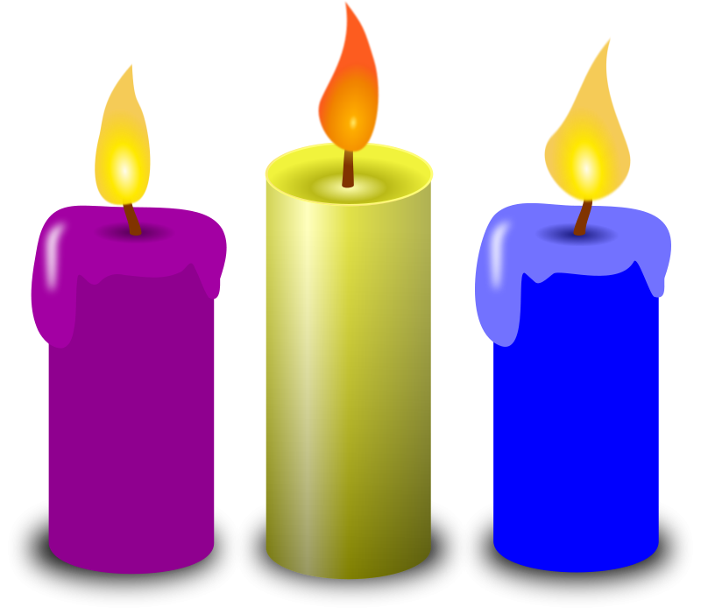

* 1. Using the scatter plot, determine if there is an association between the weight of a candle and how long it burns. Describe any trends or patterns you observe in the data including clusters and outliers.
  2. **Bonus:** How much would a candle have to weigh to burn for one year? Show your thinking as you TRY to determine the answer.

**Directions:** Describe the association between x and y. Circle any clusters in the data. Put a star by any points that appear to be outliers.

|  |  |
| --- | --- |
| 3. | 4. |
|  |  |
|  |  |
|  |  |