**Name:_________________________ Date:_______________ Per._______ Score:_____**

**U4 HW # 1** *Measuring the Slope of Stairs and Ramps*

1. Fill in the blanks
2. Define Slope in words. Slope =

3

2

1. In the picture to the right, the rise is_________ units,

and the run is________ units. Thus, the slope of

this line is_____.

1. Suppose you want to make a skateboard ramp that is **not** as steep as the one show below. Write down two different slopes that you could use.
3. Find the slope of the waterslide. Calculate it in two different ways.

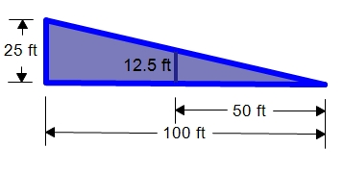

1. Roadway signs such as the one to the right are used to warn drivers of an upcoming steep down grade that could lead to a dangerous situation. What is the grade, or slope, of the hill described on the sign? (Hint: Change the percent to a decimal and then change the decimal to a fraction)

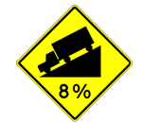

### **Directions:** Write each fraction in its simplest form and circle whether the result is a positive or negative number.

|  |  |  |  |
| --- | --- | --- | --- |
| a. $$-\frac{6}{8}$$ | b. $$\frac{-10}{-6}$$ | c. $$\frac{20}{-26}$$ | d. $$\frac{7}{21}$$ |
| Positive NumberNegative Number | Positive NumberNegative Number | Positive NumberNegative Number | Positive NumberNegative Number |
| e. $$\frac{-6}{-15}$$ | f. $$\frac{-21}{9}$$ | g. $$\frac{11}{33}$$ | h. $$\frac{12}{15}$$ |
| Positive NumberNegative Number | Positive NumberNegative Number | Positive NumberNegative Number | Positive NumberNegative Number |

### **Directions:** Solve the following equation for x and verify. Show all steps.

$-20=-4x-6x$

$-\left(7-4x\right)=9$

$x+5=-5x+5$

$3n-5=-8(6+5n)$

**Leave this World Better than it was when you got here! – Stephen Covey**