**Name:_________________________ Date:_______________ Per._______ Score:_____**

### U13 HWK #2 *Operations with Scientific Notation*

1. Find each product or quotient. Write your answer in scientific notation.

|  |  |  |
| --- | --- | --- |
|  |  |  |
|  |  |  |
| 1. What is 4 millionths multiplied by 5 ten-thousandths? |  | 1. How much is 30% of 170 million? |
|  |  | 1. 145,000 is what percent of 4 million? |

1. In a class action lawsuit, 4,000 claimants were offered an $800 million settlement. How much is that per claimant? Change the numbers into scientific notation to calculate.

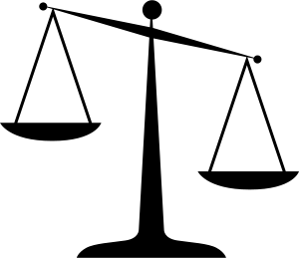

1. A cable company earned $125 million in one year. The next year they earned $312.5 million dollars. Estimate how many times bigger their profit was the second year compared to the first year.
2. There are about atoms of hydrogen in a mole of hydrogen. How many hydrogen atoms are in moles of hydrogen?
3. During the year 2013 approximatelypennies were minted (made by the U.S. Mint). In the year 2000 approximatelywere minted. Estimate how many times more pennies were minted in the year 2000 compared to the year 2013. Give a possible explanation for the decline.

.

1. Find each sum or difference. Write your answer in scientific notation.

|  |  |  |
| --- | --- | --- |
|  |  |  |
|  |  |  |
| 1. What is ten thousand plus 125,000? | 1. What is the difference between 4 hundredths and 8 ten thousandths? |  |

|  |  |
| --- | --- |
| Ocean | Area (sq miles) |
| Arctic |  |
| Atlantic |  |
| Indian |  |
| Pacific |  |

1. The areas of 4 major oceans on the Earth are shown in the table below.
2. How many square miles do the oceans cover all together? Write your answer in scientific Notation using 3 significant figures.

1. How many more square miles does the Atlantic Ocean cover than the Arctic Ocean? Answer in scientific notation with 3 significant figures.
2. The surface area of the earth is  square miles. What percentage of Earth that is covered by the oceans listed above.
3. The mass of the Sun is about kg. The mass of the Earth is about kg. How many times bigger is the mass of the Sun is than the mass of the Earth?
4. A neutron has a mass of kg and an electron has a mass of ****kg.

Determine how many times smaller the mass of the electron is than the mass of the neutron.