Name: _______________________________________ Date: ___________ Per: _______
Graphing Lines in Slope-intercept Form - Stained Glass Window Enrichment Activity
Directions: Circle four linear equations in each box. Use your knowledge of slope and y-intercept to graph these sixteen linear equations on the coordinate plane provided.
Copy the equation into the boxes below. Identify m and b from each equation you choose. Make sure the equations are in slope-intercept form before you graph the line. Draw each of the linear equations on the graph from edge to edge and number them according to the where you completed the work.
When you are done graphing the sixteen equations, use markers to color each section and create a stained glass window.
1. | 5. | 9. | 13.
2. | 6. | 10. | 14.
3. | 7. | 11. | 15.
4. | 8. | 12. | 16.
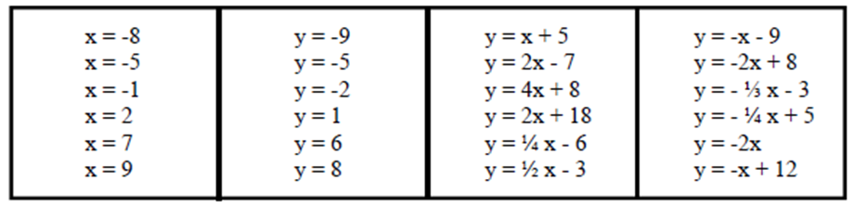

$$y-4x=8$$
$$4y=-x+20$$
$$3y=6x+9$$
$$-2x=y$$
$$2y-x=-6$$
$$3y+9=-3x$$
$$y=x+5$$
$$y=-x-9$$
$$y=2x-7$$
$$y=-2x+8$$
$$y=\frac{1}{4}x+8$$
$$y=-\frac{1}{3}x-3$$
Please color with colored pencils or crayons (markers will bleed through).

