Name:__________________________________ Date:_______________ Per._______
U4 CWK # 4 Finding Slope from Two Points

Calculate the slope of the following graphs:
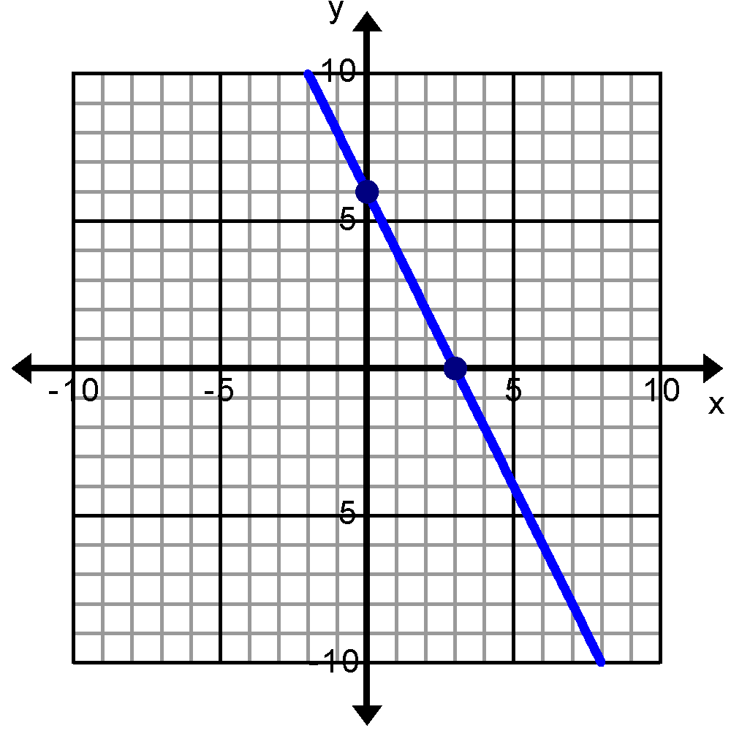 | 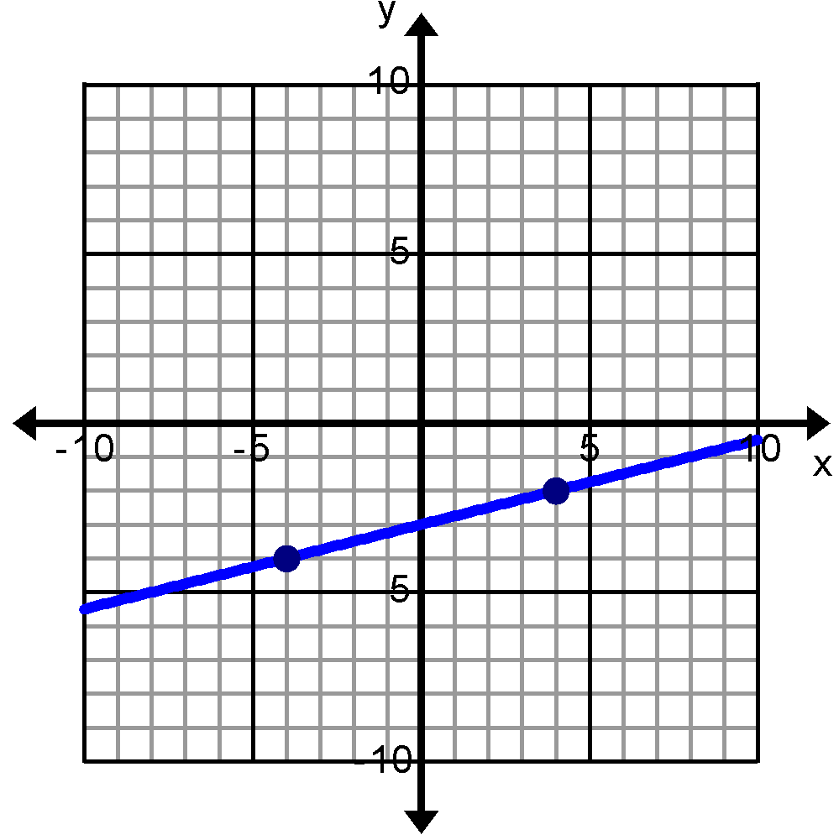

Graph the following pairs of points. Use the graph to determine the slope.
- points: (4, 3) and (0, 1)  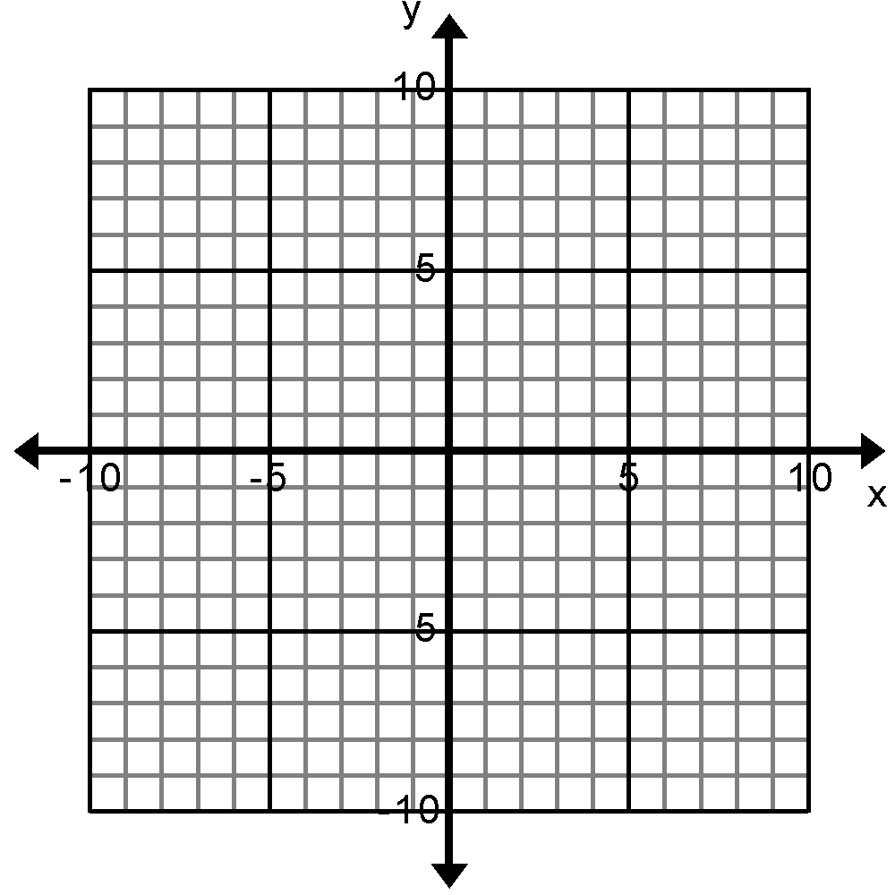 | - points: (1, 4) and (-2, 6)

Find the rise and run and slope of each line shown below. You will have to think of a way to use the coordinate points to find the rise and run.

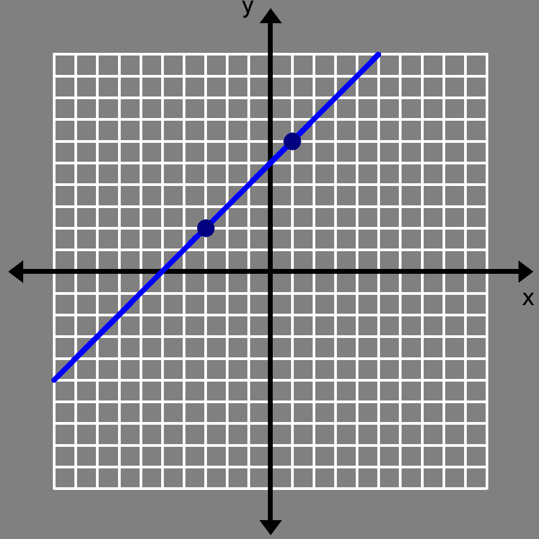  G(-3,2)  H(1,6)  Rise_____  Run______ m________ | 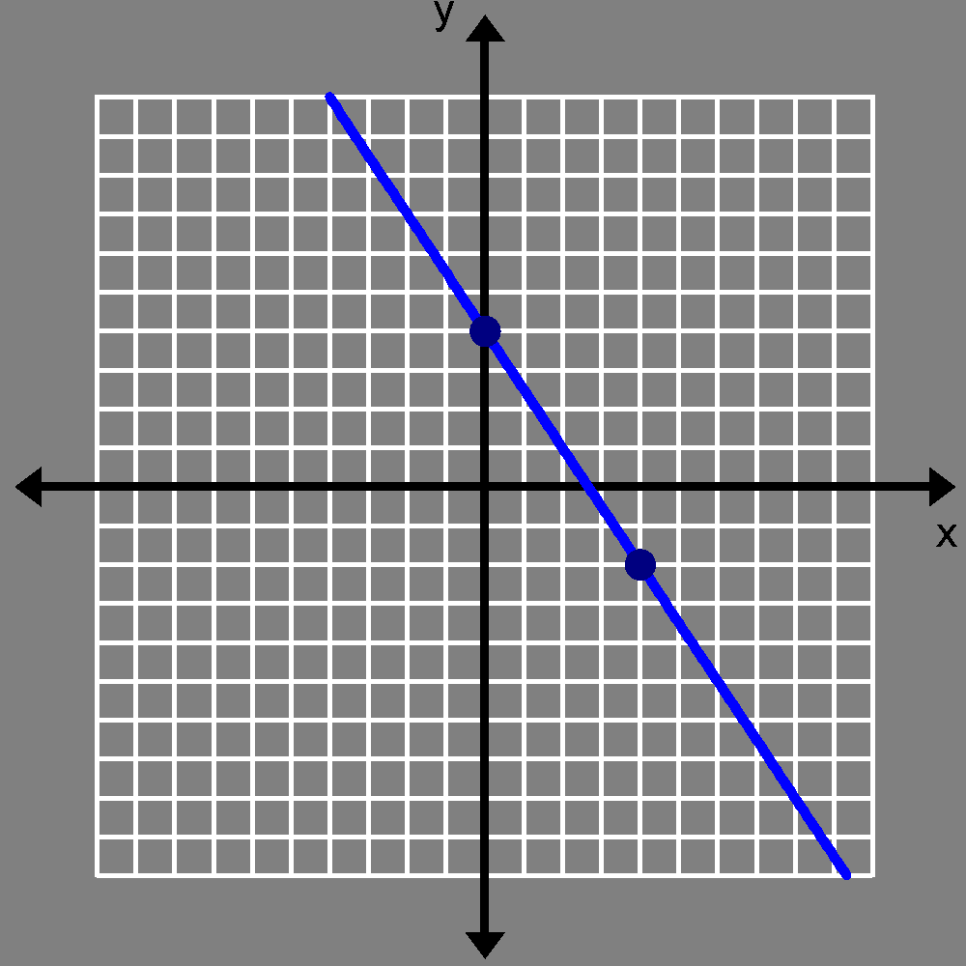  I(0,3)  J(4,-2)  Rise_____  Run_____ m________ | 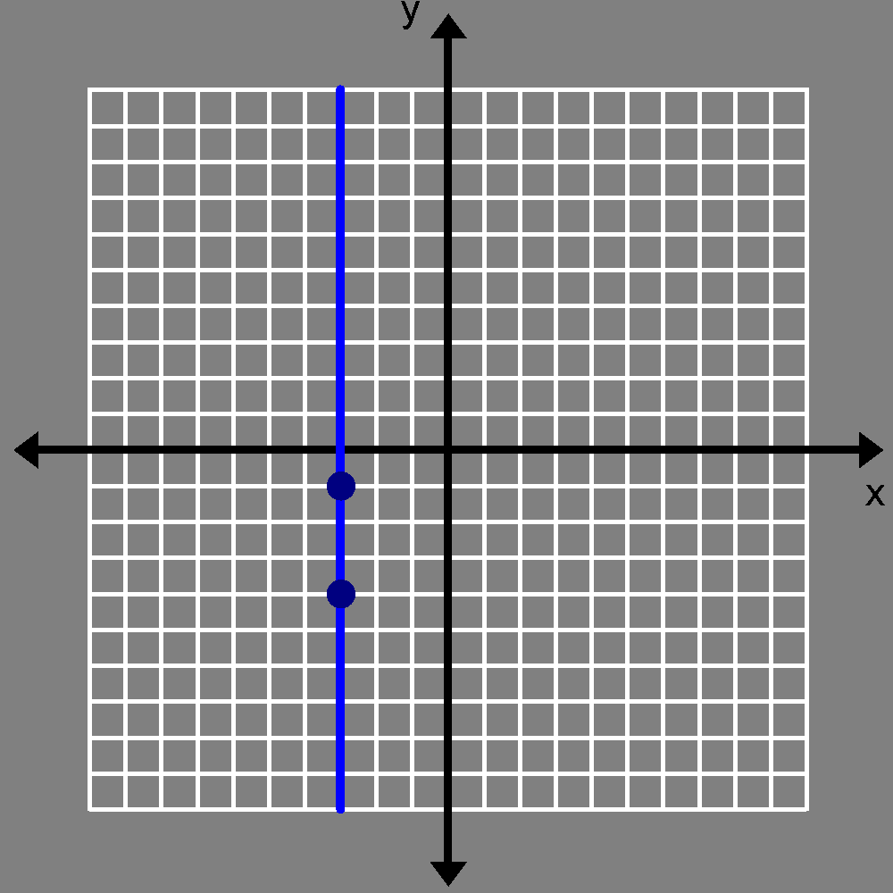  K(-3,-1)  L(-3,-4)  Rise______  Run______ m_______
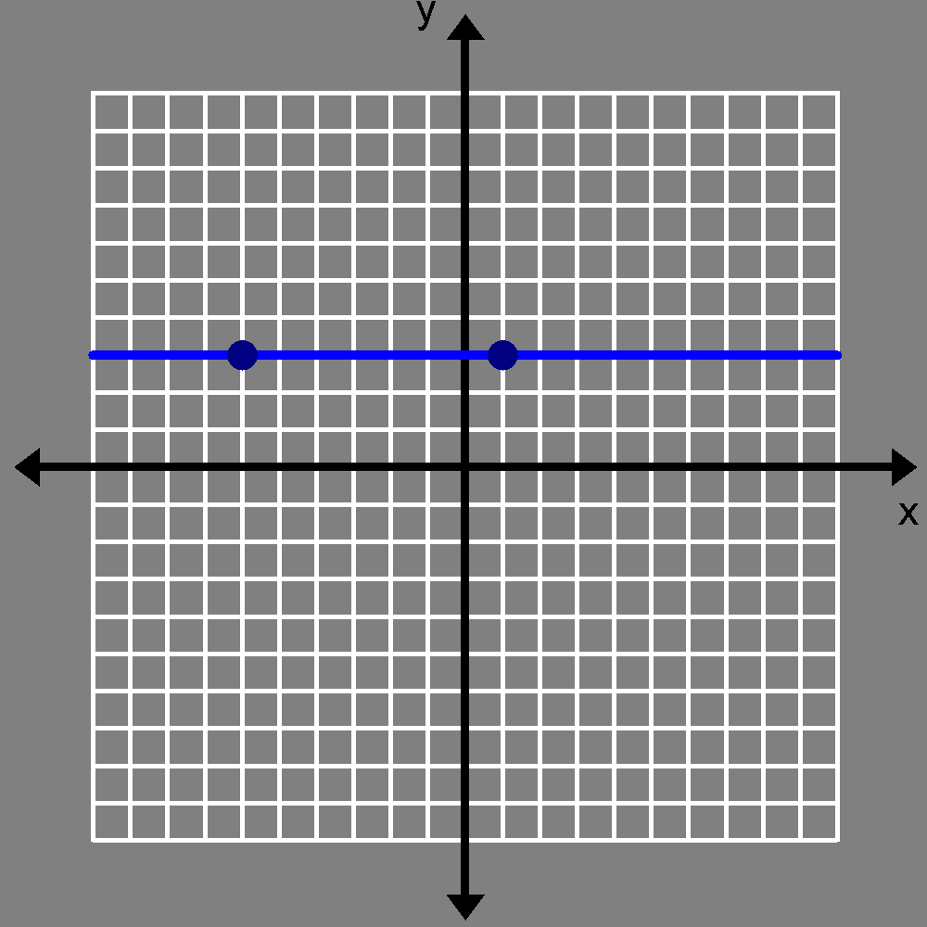  M(1,3)  N(-6,3)  Rise______  Run______ m________ | 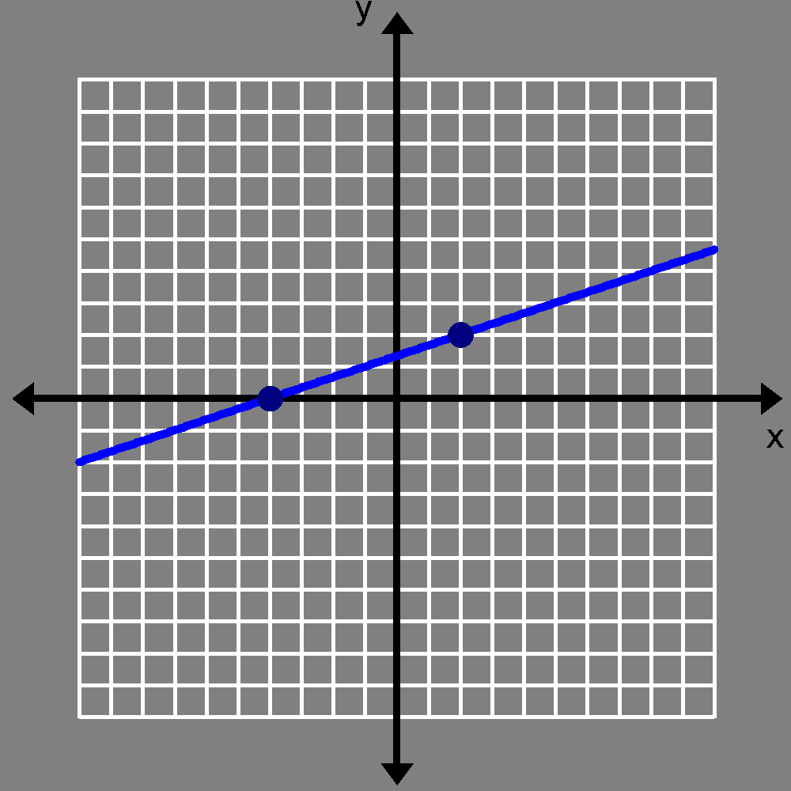  P(2,2)  O(-4,0)  Rise______  Run______ m______ | 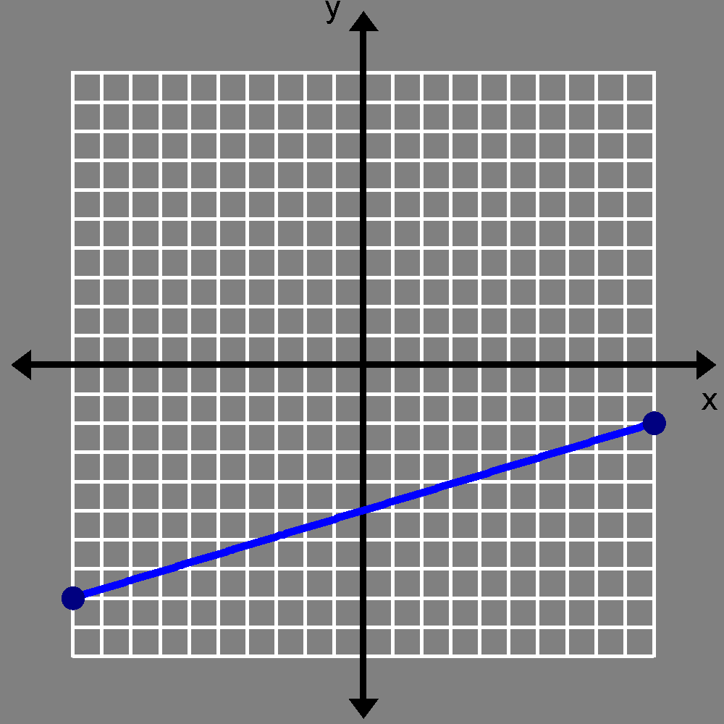  R(7,-10)  Q(1,8)  Rise___  Run______ m___

- Graphing points can be time-consuming. Develop a procedure for calculating the slope without graphing each point. Discuss and compare your method for calculating slope without using right triangles on a graph with someone else.

- Now discuss this formula: slope = m = What does it mean? How does it work?

Fill in the missing information in the problems below. Use the empty box to calculate slope using the formula, 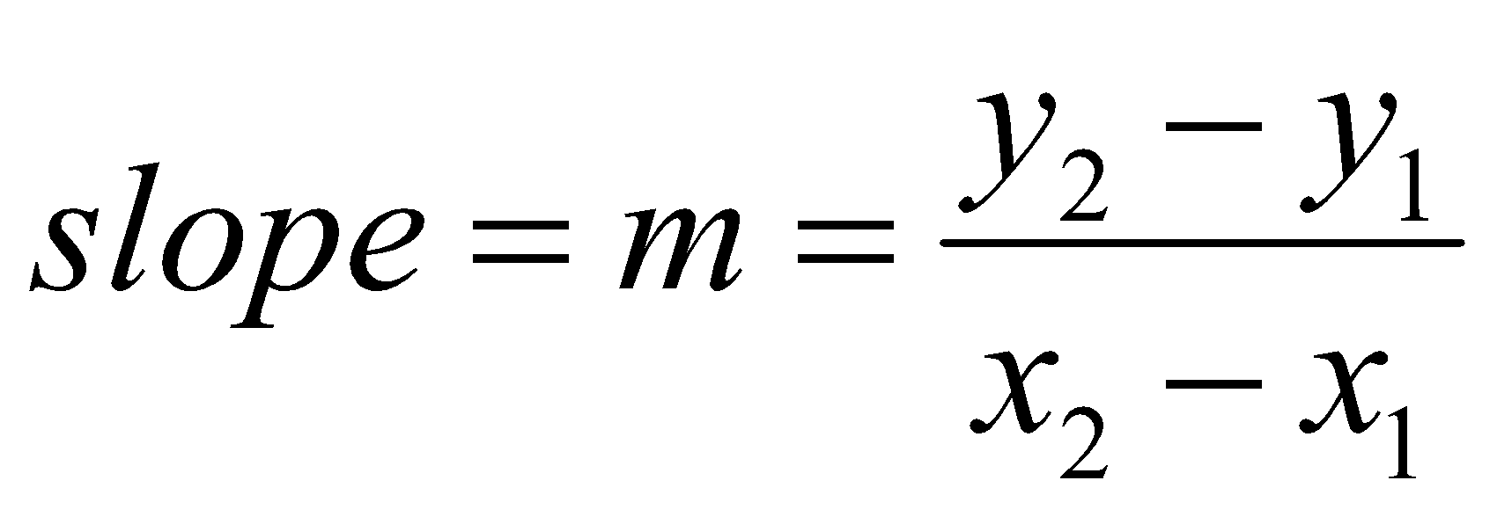. The first one has been done for you.
- (-4, -4) (1, 6) | - (-3, -6) (6, 0) | - (4, -3) (-5, 9) | - (-4, -2) (2, 1)
$m=\frac{6--4}{1--4}= \frac{10}{5}$ | $m=\frac{0--6}{6--3}= \frac{}{}$
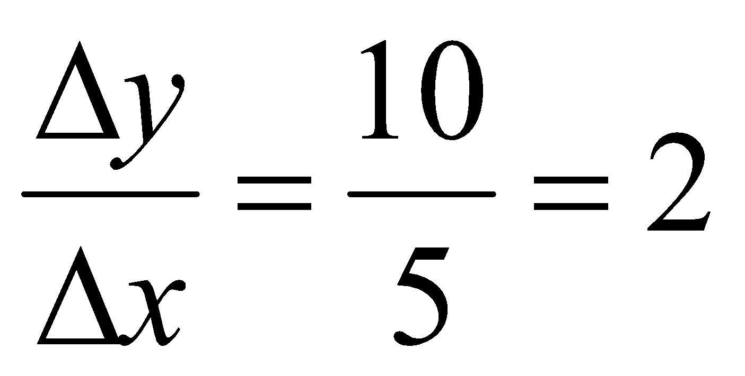 | 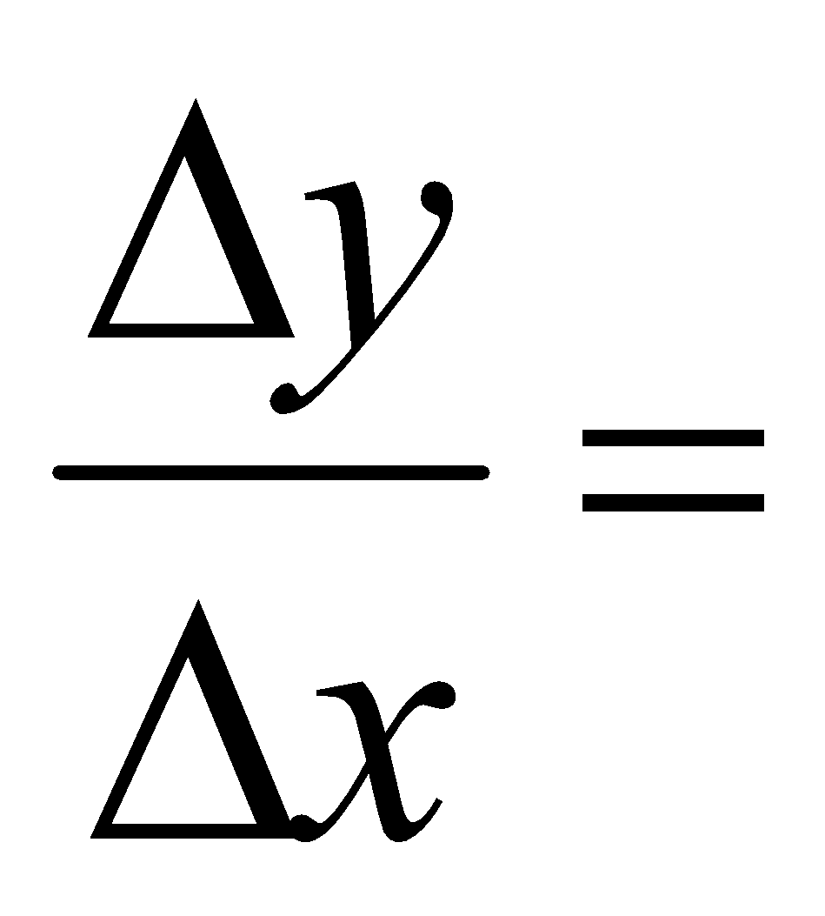 | 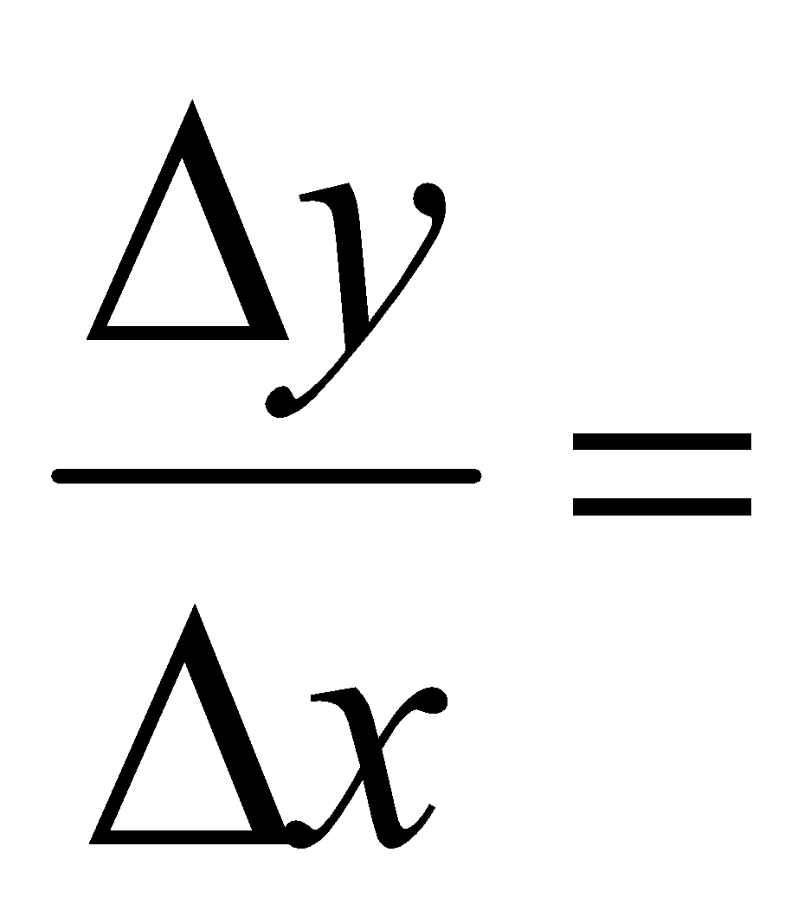
Sketch the line: | Sketch the line: | Sketch the line: | Sketch the line:

- (-3, -5) (5, -5) | 21. (-5, -7) (-5, -3) | 22. (-3, -1) (-1, -3) | 23. (-1 , -7) (0, -2)
Sketch the line: | Sketch the line: | Sketch the line: | Sketch the line:

24. ( __ , __) ( __, __ ) | 25. ( __, __ ) ( __ , __ ) | 26. ( -2, -7) (-1, -3) | 27. ( -7, 6) (6, -7)
$m=\frac{1-4}{6--3}= \frac{}{}$ | $m=\frac{-4-5}{2-2}= \frac{}{}$
Sketch the line: | Sketch the line: | Sketch the line: | Sketch the line:

Now that we have worked on graphing points and finding slopes, what do you think might be a common misunderstanding between graphing a point and finding or using the slope of a line?

Write down your thoughts:

IMPORTANT: This is the biggest misconception you will have ALL year!!
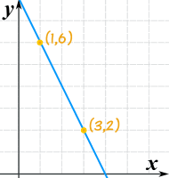
Graphing a point: Finding or using slope:
Move x spaces first, Count y spaces first,
then move y spaces. then count x spaces.

